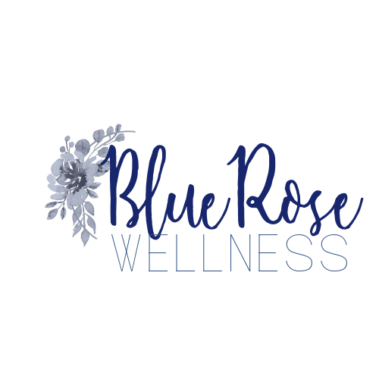

Week 1

Strength Workouts
BlueRose Balanced Bodies

OVERVIEW
Each strength workout needs to be completed with an off day in between. So an example could be: M, W, F, or T, Th, S, etc. Just make sure there is a day off in between.

Reps are the numbers of times you perform the exercise,
Sets are the number of times you complete those reps.
Take 30 seconds between sets to rest, stretch, recover and drink water.

EACH WORKOUT should be started with a brief 2- 3 minute warm up and a 5-10 minute cool down and stretch.

Equipment needed: 1-2 sets dumbbells. 3-5 lbs and 8-15 lbs. (This will all depend on your current fitness level).
Resistant band that can be anchored.
Small exercise pilates ball or any playground type ball. (dollar store, walmart, etc.)
Larger exercise ball. (nice but not needed).

If you have access to a gym you will have all things you need to use there.

Day 1
- Squats with dumbbells- 10 reps X 3 sets
- Lunge w/twist (dumbbell or weighted medicine ball) 20 (alternating legs) reps X3 sets
- Straight leg deadlifts (dumbbells, bar and plates or resistance band tethered to secure base) 10 reps X 3 sets
- Elbow to hand planks -8 reps X 3 sets
- Incline push-ups-10 reps X 3 sets
- Narrow Rows w/dumbbells - 10 reps X3 sets
- Lat pull downs- (resistant band or pull bar machine) 10 reps X 3
https://rumble.com/voyudf-loaded-barbell-squat.html?mref=3n5vx&mc=aqfly
https://youtu.be/DR97qpXweI0
https://youtu.be/mr0N2-lKvhg (bar/dumbbells)
https://youtu.be/gUhTvDJQ0Rw (band)
https://youtu.be/T0L6AMKsJCA
https://youtu.be/2FKy1DOpkH0
https://youtu.be/DAsPCmehzE4
https://youtu.be/MFms8ZHW18s (machine)
https://youtu.be/frphU08LMwI (band)

Day 2

- Single Isolated Bicep curls- 10 reps (each arm) X 3 sets
- Tricep Dips- 10 reps X 3 sets
- Tricep kickbacks behind the knees- 10 reps X 3 sets
- Mountain climbers- 30 seconds(rest 30 between sets) X 3
- Bicycle for core- 30 seconds (rest) x 3 sets
- Reverse Plank- 30 seconds (rest) x 2 sets
- Shoulder press- 10 reps X 3 sets
- Lateral raises- 10 reps X 3 sets

https://youtu.be/t1AsdHG_PMk
https://youtu.be/5qRrnTxexmg
https://youtu.be/a6102VoQhDA
https://youtu.be/yJQR4Q_HzWs
https://youtu.be/_P5Xl-j-nmQ
https://youtu.be/1XNxfe0Ava8
https://youtu.be/GaoSum3s1nQ

Day 3

Barre Above Class

https://youtu.be/Jh056AbDlYo

NOTE:
ALWAYS modify if need be. Ex: Pushups on toes for many women need to be done on knees. Watch this example here:
https://youtu.be/utzhPQuXWcA

If being on your knees is uncomfortable still, try wall pushups! Also can be used in the elbow to plank pushup:
https://youtu.be/YB0egDzsu18

BURNING muscles are a good thing. PAIN is not. If you feel any PAIN or breathlessness, stop exercising and if need be consult your health practitioner.

